**Brooklyn torah gazette**

**For parshas vayeisHev 5781**

Volume 5, Issue 14 (Whole Number 214) 26 Kislev 5781/ December 12, 2020

**Printed L’illuy nishmas Nechama bas R’ Noach, a”h**

This means, if one doesn't provide food to those who need it, he is held responsible for everything wrong that happens due to this error.

**The Mission**

**By Rabbi Y.Y. Jacobson**

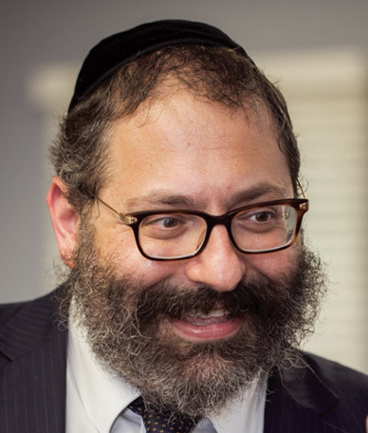

The late astrophysicist, Professor Velvel Green, who worked many years for NASA, once related the following story.

Many years ago, Dr. Green shared, a noted scientist delivered a lecture at a Space Science Conference on the broader aspects of the National Aeronautics and Space Administration Program in the USA. Among other things, the lecturer drew a parallel between the problems which will face space explorers in the future and our current conditions on earth.

**A Hypothetical Manned Voyage to Alpha Centauri**

Using a hypothetical manned voyage to the nearest star, Alpha Centauri, as an example, he emphasized the remarkable engineering, biological and sociological problems that would be encountered during the execution of this enterprise. Since the star is 4.3 million light years away, a spaceship travelling at 1,000 miles per second would require more than 800 years to get there and another 800 years to get back.

Any original crew we launched would not survive for even a fraction of the mission’s duration. Instead, we would have to “man” the capsule with men and women who would have children who would carry on the mission. These children would themselves have children, continuing this for 1,600 years. Ultimately, after many generations, the remote progeny of the original crew would complete the mission.

p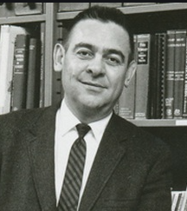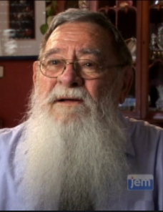

**Before and After photos of NASA scientist Professor Velvel Green**

**The Spaceship Would Have to be Completely**

**Self-Sustaining and Self-Supporting**

This interstellar spaceship would have to be completely self-sustaining and self-supporting. But the lecturer pointed out that the engineering and technical problems are only one side of the coin. In the spaceship the crew would have to learn to tolerate each other, generation after generation. They would have to learn, and learn quickly, that you don’t blow up only part of a spaceship.

And then the speaker touched on a key topic: Would the fiftieth generation, after a thousand years, still share the aspirations of their pilgrim fathers who set out from earth so long ago? How, indeed, can you convey to a generation still unborn the basic information about where they came from, where they are going, why they are going there, how to get there, and how to get back?

One of the scientists stood up, and to my surprise and delight, declared: “If we could figure out how the Jewish people managed to survive these thousands of years, we’d have our answer!”

What a magnificent answer. Because to a Jew this story is no mere fantastic flight of imagination; it captures our millennia-long narrative. Almost four millennia ago, Abraham heard a call to become a blessing for all mankind. Over three thousand years ago, at Mount Sinai, we were launched with specific instructions and suitable maps. And we were told that we ought to transmit this mission to our children and grandchildren, for generations to come.

What was the mission? To reveal that the universe has a soul, that humanity has a soul, that each of us has a soul. That we are living in G-d’s world, and our mission is to transcend our superficial shells and reveal the Divine in each of us. Our journey, we were told, is not over till we bring Moshiach, when the truth of reality will be revealed and exposed even to the physical eye.

**Knowing Who was the Project Officer**

For more than a hundred generations we knew where we came from, were we were going, why we were travelling, who was the Project Officer, and how to get back. We had no real difficulty in transmitting this intelligence unbroken from generation to generation—even to generations who were not physically present during “take off” at Sinai. How? Because the Torah, our Divine logbook, contained macro and micro guidance. Notwithstanding all challenges, this logbook has met the only real criterion of the empirical scientists—it worked. Our presence demonstrates that it worked.

As long as we did not allow an interruption in the transmitting of Torah from generation to generation, the mission and the people remained intact.

**The Challenge**

But somehow, not too long ago, a “space” emerged in the middle of this long and incredible journey. A generation of “astronauts” arose who decided that they could write a better logbook. They thought the original was old-fashioned, restraining, complicated, and irrelevant to the problems of modern times. They lost their “fix” on the celestial reference points.

Many of them know something is wrong; but they cannot pinpoint the malfunction and cannot get back on course. Our mission today is to teach by example how there is indeed no gorge and no gulf between Sinai and modernity. It is one continuous uninterrupted chain, and—unlike with Darwinism—there is no missing link.

The glorious narrative of our people is that we never allowed for an intergenerational gap. The same Shabbos our grandmothers celebrated 2500 years ago, we still celebrate. The same tefillin my great grandfathers donned in Georgia 300 years ago, I still wrap today. The same texts Jewish children in Florence and Barcelona were studying 700 years ago, my children study today.

Abraham began the story, Moses consolidated it, and we will complete it.

*Excerpted from the December 1, 2020 edition of The JEWISH VUES.*

**Rabbi Berel Wein on**

**Parshat Vayeishev 5781**



This week's Torah reading begins with a simple statement that our father Yaakov settled in the land where his father had lived his entire life – the land of Canaan. Why is it so important that the Torah should bother to mention that this land was the land of Canaan?

It seems obvious that we know from previous chapters where the family of Yaakov lived, and that it was the land of Canaan that would later be called the land of Israel. What special significance is there now when the Torah adds to the original text the descriptive phrase that it was the land of Canaan?

**Nothing Appears in Torah at Random**

As usual, in discussing such issues the commentators over the centuries have added their insights and wisdom to help us understand and appreciate the greatness and message of the biblical text itself. Nothing appears in the Torah at random, though there are a few instances when the Talmud does identify certain words and phrases as being additional decorations of beauty on the Torah text. Considering these extraneous words, many explanations and comments have been offered throughout the millennia of Jewish life and scholarship. Each of these elucidations adds understanding to the holiness of the text.

**The Importance of the Order of Phrases**

My addition to this wealth of scholarship is the idea that the phrase “the land of Canaan” occurs at the very end of the verse, after it is stated that Yaakov dwelled in the land of his father. The order of the phrases is important because it teaches us an important lesson on how to view our attachment to the land of Israel.

Yaakov came to live there not because it was the land Canaan – its physical location, its landscape, and its geographical structure. Rather, his entire attachment to it was that it was the land where his father had dwelt, and that his father did so under the commandment of the Almighty.

Thus, the attachment and bond of the Jewish people, the descendants of Yaakov are not based on purely external considerations. Rather, it is based upon our religious heritage and family tradition that has, over the ages, taught us that this is our home, this is where we belong and where we should live.

**The Attachment of the Jewish**

**Land Has Never Wavered or Waned**

Over the long exile of the Jewish people, this attachment to the land has never wavered or waned. It is interesting that even when the Zionist movement had to vote whether to accept the country of Uganda as a substitute for the land of Israel, even the most secular of labor Zionists refused to allow this to happen. For the Jewish people throughout the ages, it was always about settling in the land of Israel and nowhere else.

The failed colonies of Baron Hirsch in South America and the rest of the world, as compared to the successful colonies of the Baron Rothschild in the land of Israel, only serve to illustrate this point in historical terms. Yaakov is going home, and he knows exactly where home is located.

*Reprinted from the Parshat Vayeishev 5756 edition of the L’Chaim Weekly, a publication of the Lubavitch Youth Organization.*

**The Two Basic Principles of**

**Joseph’s Dreams for All Jews**

**From the Talks of the Lubavitcher Rebbe**

**Rabbi Menachem Mendel Schneerson, Zt”l**

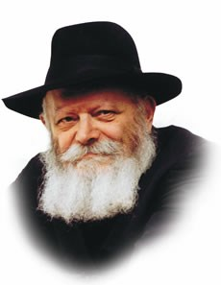

This week's Torah portion, Vayeishev, speaks of Joseph's two dreams, both of which share the common theme of bowing down and submission.

In the first dream, the brothers' sheaves place themselves around Joseph's sheaf and bow down; in the second, the sun, the moon and eleven stars prostrate themselves before him.

**The Binding Sheaves in the Field**

The first dream, in which Joseph and his brothers are "binding sheaves in the field," is symbolic of the physical world, and alludes to a lower level of man's service of G-d. The second dream, involving celestial bodies, symbolizes man's higher faculties and thus a higher level of his service. Both dreams, however, express the same idea: bowing down and self-nullification before Joseph.

In a larger sense, man's entire purpose in this world is to "bind sheaves in the field" -- uniting the disparate elements of existence into a unified whole.

Upon its descent into the physical world, the soul must contend with a new plane of existence, in which reality appears dissociated from G-dliness.

Its mission is to utilize its intellectual and emotional powers -- and indeed, all it comes in contact with during its sojourn on earth -- and reunite them with G-d.

**An Additional Necessary Step**

From Joseph's dream, however, we learn that an additional step is necessary to complete our service -- binding our "sheaves" with that of the tzadik.

Just as the limbs of the physical body must be connected to the head and obey its instructions, so too must every Jew connect himself to the Nasi, the leader of the generation, and follow his directives.

Joseph's second dream alludes to an even higher level of spiritual service, that which is reached after having perfected all of the above. For the Jewish soul cannot complete its mission solely through its own powers; every Jew, no matter what his spiritual achievements, must "bow down" to Joseph -- to the tzadik, the leader of the generation -- in order to bring perfection to the Jewish people as a whole.

**Two Basic Principles in Our Service of G-d**

Thus we learn from Joseph's dreams two basic principles in our service of G-d: First, it is necessary for the Jew to show personal initiative, "binding" our "sheaves" by the sweat of our brow to unite the physical world with G-dliness. Second, submission to the Nasi of the generation is required by all Jews, even those who have attained the highest levels of service through their own efforts.

In such a manner do we form the "vessel" in which the abundant influence and blessing of the tzadik, the "foundation of the world," can be received by all.

*Adapted from Likutei Sichot of the Rebbe, Vol. 3*

*Reprinted from the Parshat Vayeishev 5756 edition of the L’Chaim Weekly, a publication of the Lubavitch Youth Organization. Adapted from Sefer HaSichot of the Rebbe, Vol. 3*

**Chanukah Powers**

**By Rabbi Moshe Meir Weiss**

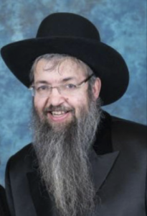

As we get ready for the very sweet festival of Chanukah, it behooves us to brush-up on its spiritual messages. In this way, we can ensure that it doesn’t become a mere season of gastronomic delight such as latkas and sufgoniot (jelly doughnuts) nor will we fall into the trap of allowing Chanukah to become, chas v’shalom, an Xmas look-alike.

A common thread that runs through most of the amazing events of Chanukah is the element of mesiras nefesh, self-sacrifice, of the valorous Jews during the memorable era of the Chashmanoim.

**Looking for a Needle in a Haystack**

Whether it was the rabim b’yad m’atim, the many in the hands of the few, giborim b’yad chaloshim, the mighty in the hands of the weak, the heroic self-sacrifice of the brave Macabees to defend the Holy Temple and the lives of their brethren from the wicked Syrian-Greeks, whether it was the legendary Chanah and her seven sons who, with amazing courage, chose death rather than bow down to Antiochus haRasha’s idol, or the zealous search of the Kohanim to find a single jar of oil with the seal of the Kohein Gadol, a search that can be compared to looking for a needle in a haystack when they could have allowed themselves the Talmudic heter, allowance, of tumah hutra b’tzibor, that when the entire congregation is contaminated, one can use even defiled oil, but they demonstrated amazing mesiras nefesh in passionately wanting to fulfill the mitzvah in its best possible way.

Or, the amazing valor of the daughter of the Kohein Gadol who, instead of succumbing to the wickedness of the Syrian-Greek governor, protected her Jewish modesty with an incredible act of bravery, killing the wicked official and jump-starting the Jewish conquest.

**Chanukah is a Time to Take**

**Stock of Our Mesiras Nefesh**

Chanukah therefore is a time to take stock in whether we have this element of mesiras nefesh in our spiritual lives. When we are tired, do we still push ourselves to get up early to make minyan – or do we succumb to temptation and say our prayers quickly at home before dashing off to work? Do we exercise self-sacrifice in pushing ourselves to attend a shiur after a hard day’s work – or do we cave in to our physical laziness and just go home and read the paper?

In this area, Chanukah should jog us to make a reality check. Is there an element of mesiras nefesh in our relationships with our children? Do we find the time – although there is never enough time – to take interest in our children’s learning, in their character development, in their personal happiness? All of these objectives are mitzvahs of the highest priority, since if we, their parents don’t attend to these needs, who will?

Do we have the spiritual bounce our steps to use a Sunday or any day off to provide pleasure for our spouse – thereby ensuring the Shechina will permeate our homes? Mesiras nefesh doesn’t only mean putting your life on the line for your spiritual beliefs. Rather, anytime we push ourselves beyond our natural physical tendencies in order to fulfill the will of Hashem, we are following in the footsteps of the great Macabees, the heroes of Chanukah.

**A Fascinating Story About the Venerable Rav Shach**

The Aleinu Leshabei-ach, on Parshas Vayishlach, tells a fascinating story about the venerable Rav Shach, Zt”l, Zy”a. Rav Shach, already a very old man, had to spend some time at the hospital. One day, he informed his family that he desired to go one floor down to visit a man who was also staying at the hospital. Rav Shach had known that this man was treating his wife poorly. He wanted to talk to him once again about adopting better marital behavior.

The family was aghast as Rav Shach was ill and very aged, yet he wanted to get up from his sick bed and go down a flight of stairs all for a shalom bayis discussion. Despite their pleas, Rav Shach was adamant. They then suggested that instead of Rav Shach going downstairs, they would ask the man to come up to Rav Shach’s room. This, too, he vehemently vetoed.

At this point, when reading this story, I thought to myself that Rav Shach’s reason probably was that he was banking on the impression he would make on the man by leaving his sickbed and trekking downstairs. Perhaps this act would impress him to realize the severity and importance of the issue!

**Getting Out of His Sick Bed to Help Save a Marriage**

This just shows how little I understand the minds of our gedolim. Rav Shach went on to explain why he insisted on going down to the room himself. He elaborated that he had worked on this couple’s marriage many times to no avail and therefore he felt that perhaps if he took heroic measures to be moser nefesh – to get out of his sick bed to help save a marriage, Hashem would see his self-sacrifice and perhaps, in that merit, bless his efforts with success.

This vignette introduces an entirely new angle to mesiras nefesh. Sometimes a spouse says, ‘Why should I go through so much trouble? My mate won’t appreciate it anyway?’ or a parent thinks, ‘Why am I investing so much energy in this child. S/he just takes it for granted?’ Even if these conjectures are true, the superhuman effort might still be effective for Hashem might take note of this additional exertion and in that merit might bless us with Divine assistance at succeeding in our marriage or in the chinuch of our child.

In the merit of our mesiras nefesh – both small and large examples, may Hashem bless us with long life good health and everything wonderful.

Here are some tips for the days ahead.

**The Last Day of Chanukah is the Final “Gmar Din”**

Chazal teach us that the last day of Chanukah is the final “gmar din.” Since this is so, the month before it is like an Elul and can be used wisely for a final chance at teshuvah and making peace with people.

Chazal teach us “Gedola mitzvah b’shaata – Great is a mitzvah in its proper time.” As this is the case, we should make every effort, when possible, to light the Chanukah candles in the proper time; forty-five minutes after sunset (according to most opinions). At the very least, we should try hard to do this on Motzei Shabbos and Sunday!

Although family gatherings are a delicious part of Chanukah, they should be planned around the lighting of the neiros in the proper tine – and not the other way around! It is okay to blow out the candles after they have remained lit for the shiur – and then one can go to join family, parents, children, friends and neighbors. (During COVID-19, one must consider very carefully about having family gatherings at all.)

Great care should be exercised with the hadlaka on Erev Shabbos. The lighting should be done leaving ample time for the women to make their eighteen minutes before shkia hadlaka. It is preferable to daven Mincha after the hadlaka if that will help ensure that everyone will light on time! Remember chilul Shabbos takes priority over any aspect of lighting the candles!

**Never Leave Candles Unattended when Children are Around**

When children are around, never to leave the candles unattended – especially on Friday night! Also remember to keep the neiros away from the drapes.

The Gemora in Shabbos informs us, “Kol haragil b’neir havyan lo banim talmidei chachomim – Whoever is careful with candles will have children who are Torah sages.” In part, this refers to the mitzvah of Chanukah candles. Thus, the stakes are high to do this lofty mitzvah in the most beautiful way possible. Having a nice menorah, keeping it clean, putting it in the right location, saying the blessing with proper kavanah (concentration), and gazing at the candles and wicks, contemplating the great miracles of the Chashmanaim era, are all part of the meaningful fulfillment of this mitzvah.

According to many Chassidic masters, the custom of Chanukah gelt is an opportunity to teach children to give tzedaka from their own money.

**The Significance of Latkes and Sufgoniot**

Latkes and sufgoniot are the standard scrumptious Chanukah fare. This is because they are prepared with oil and therefore help to commemorate the great miracle of oil on Chanukah. In addition, it is an excellent idea to introduce cheese platters at a Chanukah banquet.

This commemorates the miracle that occurred with the daughter of Mattisyahu, Kohen Gadol (Medrash Maseh Chanukah). When the Syrian Greek governor abducted her, she got him thirsty using salty cheese. She then plied the thirsty rasha with strong wine, which lulled him to sleep. Subsequently, she killed him, which was one of the miracles that led to the Jewish conquest of the Yevonim.

The fast of Asara B’Teves commemorates the terrible event of the wicked Nevuchadnetzar setting siege to Yerushalayim. In a way, in our time the Arabs are also setting siege to Eretz Yisroel – and we should use this fast as a catalyst to pray for our brethren there, and for the speedy coming of Moshiach tzidkeinu!

*Reprinted from the November 30, 2020 email of The JEWISH VUES.*

**The Significance of the**

**Name of Chanukah**

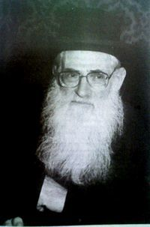

**Rabbi Chaim Friedlander**

Rabbeinu Nissim ben Reuven Gerondi z”l (Spain; 1320-1376) and several other early authorities write that the name “Chanukah” is a contraction of “Chanu Kaf-Heh” / “They rested on the 25th,” i.e., on the twenty-fifth day of the month of Kislev, the Maccabees’ war against the Greeks ended, and the Jews rested.

This requires explanation, however. Why would our Sages name the holiday after the fact that the warriors rested, rather than after the fact that the Jewish People were victorious in battle?

R’ Chaim Friedlander z”l (1923-1986; Mashgiach Ruchani of the Ponovezh Yeshiva) explains: Victory in war has two aspects:

(1) the fact that the enemy was defeated, and

(2) the fact that the fighting has ended.

The latter can, of course, occur without the former; for example, if there is a negotiated peace or if a third party intervenes. But, generally, one would expect a victor to commemorate the first aspect more than the second.

Our Sages, however, wanted to commemorate the reason why we were fighting against the Greeks. Our battle was not like the wars of nations, a quest for military victory. Rather, it was a quest to be left alone, to be allowed to study Torah and perform Mitzvot as we please, without foreign interference.

The military victory itself was of no independent significance; what was important was the fact that the Jewish People could “rest,” that they were finally free of interference.

R’ Friedlander continues: R’ Moshe ben Maimon z”l (Rambam; 1135-1204; Spain and Egypt) writes regarding the future era (in Hil. Teshuvah 9:2), “The reason all of the Jewish People and its prophets and wise men desire the Days of Mashiach is so that they will ‘rest’ from [the oppression of] the kingdoms that do not allow them to occupy themselves with Torah and Mitzvot.”

Rambam’s wording, notes R’ Friedlander, is consistent with the above explanation of what the Maccabees were celebrating and with the fact that they named the holiday “Chanukah.” (Siftei Chaim: Mo’adim)

*Reprinted from the Parashat Vayeishev 5781 email of whY I Matter, the parsha sheet of the Young Israel of Midwood (Brooklyn) as compiled by Yedidye Hirtenfeld.*

**Women at War**

By [Chana Kroll](https://www.chabad.org/search/keyword_cdo/kid/11813/jewish/Kroll-Chana.htm)

*The hall was packed. This was no ordinary wedding, but the wedding of the daughter of one of Jerusalem’s most prominent families. Leaders in the still quiet and nonviolent rebellion against the Greeks, they were respected and loved by Jews throughout the Land of Israel. Not to mention that, as priests in the Temple, the family had been looked up to for generations.*

*Amidst the elegant flowers, soft music, and the conversations of the guests, the bride suddenly stood up, walked to the center of the room, placed her hand on her chest, and tore open her gown.*

***She Stood Firmly and Addressed the Room***

*Shocked, angry, and embarrassed, her brothers rose to drag her from the room. But she stood firmly in place and addressed the room: “You who are so zealous that you would kill me, are not zealous enough to protect me from the hands of the Greek governor who will come here to assault me tonight.*

*“Did you not learn from Shimon and Levi, the brothers of Dinah, who, though only two men, killed the entire city of Shechem for her sake? Place your faith in the One Above, and He will help you.”*

*Her five brothers declared their willingness to go to war, and were answered by a voice emanating from the Holy of Holies promising victory.*

The story of the Maccabees’ brave revolt is a familiar one not only to Jews but to most non-Jews as well. I can still remember my second-grade music teacher in public school giving a brief account of the miracle of the oil before teaching the whole class “Rock of Ages.” What was left out of her account were all the details about what the Jews were really fighting for. In her eyes it was a story of the struggle for political freedom, and fit in quite nicely with news accounts of Sakharov, Mandela, and others struggling for personal and national liberty.

As I grew older and became more involved with Judaism and the Jewish community, details seeped in. Initially, the Greeks treated the Jews with greater respect than they had treated other peoples they conquered. Alexander the Great had seen the High Priest, Shimon the Righteous, in a dream, and when Shimon went out to meet his approaching army, Alexander knelt before him and pledged never to harm Jerusalem or the Holy Temple.

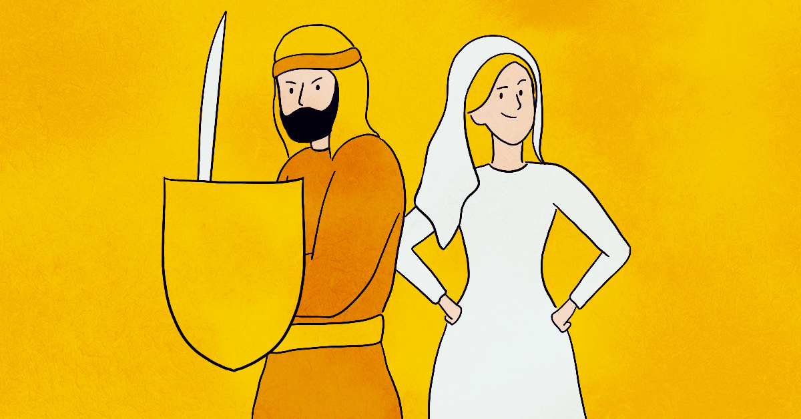

Years passed. Alexander and Shimon the Righteous both passed away. Some Jews became quite infatuated with Greek culture. But the more they imitated the Greeks, the less respect the Greeks had for us. They began to mock Judaism and enact laws against it. First they locked up the synagogues and schools. People prayed and studied in one another’s homes.

Then, the Greeks passed a law that all Jews had to write a sentence stating they had no portion in the G‑d of Israel on the horns of their livestock and on their doors. The Jews sold their livestock and removed the doors from their homes.

The Greeks passed a law outlawing circumcision. The Jews made up secret signs through which they announced circumcision ceremonies, and guests risked their lives to go wish the new parents *“Mazel Tov!”*

**The Greeks Outlawed Major Jewish Mitzvahs**

The Greeks outlawed Shabbat, the celebration of the New Moon, and Torah study. Jews hid in caves and continued to observe all three. The Greeks found hundreds of ways to try to stamp out Judaism. Jews found hundreds of ways to quietly rebel and to remain what they had always been. Then the Greek soldiers started assaulting Jewish women. The governor made a decree—unfortunately, a common one in ancient cultures—called *jus primae noctis*, “first night rights.” The governor would kidnap and assault every bride on her wedding night.

And then the Jews went to war.

The victory we celebrate on Chanukah is a victory on many levels. It is a victory of the few over the many, of light over darkness, of Jewish continuity in the face of all those who had sought, or would seek to, wipe out Judaism and Jewish history.

**It was for the Sake of Jewish Women that**

**The Macabees were Let to Declare War**

The Jewish people—men and women—defied every Greek law with enormous self-sacrifice, yet it was largely by and for the sake of Jewish women that the Maccabees were led to declare war.

The decisive moment occurred when one Jewish woman looked her brothers in the eye and told them, “You cannot let this happen to me.” It was a war, first and foremost, for sanctity—the sanctity of the Temple, the sanctity of Torah, and *the sanctity of every human being*.

Among the many miracles we acknowledge and commemorate as we kindle the lights of the menorah, we also acknowledge the simple truth of every woman’s sanctity and her right to personal safety and dignity.

It’s a detail well worth remembering.

*Reprinted from the Parashat Vayeishevv 5781 email of Chabad.Org Magazine.*

**My Grandmother and the 1922 Russian Typhus Epidemic**

**By**[**Sofya Tamarkin**](https://www.aish.com/authors/573126641.html)

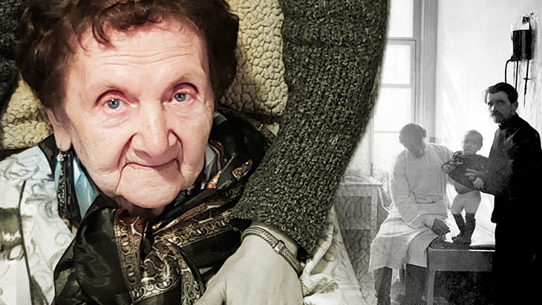

***Her father refused to believe the doctors' pessimistic diagnosis. Her miraculous survival instilled a steadfast gratitude to G-d, despite the barrage of atheistic Communist propaganda.***

In 1922, the typhus epidemic reached its peak in Soviet territory, with 25 to 30 million cases in Russia. My grandmother, Zelda, was born in 1924 right after the Communist Revolution in the midst of the pandemic. Her mother died during the birth of Zelda’s younger sister, leaving her 26-year-old father, David, to raise three little orphaned girls. The oldest, Rachel, was 5, Zelda was 2 and Olga, named after her mother who passed away, was 2 hours old. These years were filled with challenges of poverty, hunger and sicknesses.

When Zelda was 7 years old, the typhus pandemic struck their household. All three of the girls became ill with this horrible illness. They had a high fever, stomach pain, terrible weakness and rash. While my grandmother's sisters remained conscious, Zelda succumbed to the worst of this disease.

Her father paid for a doctor’s visit which was a complicated and expensive ordeal. My grandmother often recounted the story of how the doctor examined each one of the girls separately and said, "David, you are a smart man, and I will be honest with you. Your oldest, Rachel, and youngest, Olga, have a chance of survival so you should admit them to the city hospital. But the middle one, Zelda, will not live. Don't waste your money or time. She has been unconscious for three days, and she has no chance of survival."

While seemingly unconscious, Zelda was aware of every word that the doctor said. Then she heard her papa’s reply, "I will take all three of them to the hospital. I won't give up on Zelda until she stops breathing."

*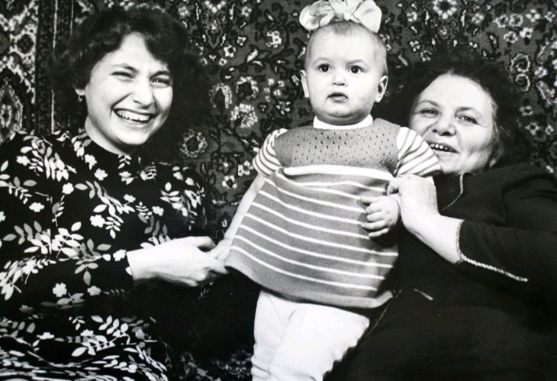****Zelda (right) with her younger daughter Vera and little Sofya in Soviet Union.***

The hospital had a big room with hundreds of beds. Papa sat on a chair near his daughters' beds. When he dozed off, he dreamed of his late wife. In his dream, she gave him four loaves of challah for each one of the girls and said that Zelda, needed an extra one to get her strength back. David was woken up by Zelda's weak tiny voice. After three days of going in and out of consciousness, she woke up and asked for a drink of water.

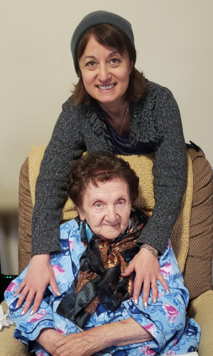

**Me and my grandmother**

Zelda survived and lived her life vivaciously, always remembering her papa's answer. She became a beckon of hope and positivity for her family and everyone she encountered.

**Recognizing Her Recovery as a True Miracle**

During her entire lifetime, Zelda saw her recovery as a true miracle and a clear message from the 'other side'. This incident made her so grateful to be alive and despite Communist atheist propaganda, she always believed in G-d. While Soviet government prohibited all religious observances, no authorities had the power to remove faith from people’s hearts. My grandmother knew that in our darkest moments, we are always guided by our Creator.

As Rabbi Lord Jonathan Sacks wrote in his book *Celebrating Life: Finding Happiness in Unexpected Places*, “Making a blessing over life is the best way of turning life into a blessing.”

**Her Motto in Life**

This was Zelda's motto in life. Orphaned by her mother’s death at the age of two, widowed at 35, raising a sick daughter under the Communist oppression, starving throughout Stalin’s regime, and surviving World War II, she never lost hope, faith or positivity. As Rabbi Schneur Zalman of Liadi famously taught, "A little bit of light dispels a lot of darkness."

The last time I saw my grandmother was on Purim day, right at the beginning of the Coronavirus Pandemic. She passed away on May 6th, 2020, almost a century after being born, due to failing health unrelated to the virus.

This coming winter, instead of focusing on the things that are unavailable, places that are closed and travel that we can’t do, let's refocus our attention to what we are privileged to have. These gifts include basic necessities like water, clean air, our warm homes, food to eat, technology that connects us to each other and millions of other things we take for granted. As our sages teach, "Who is rich? One who is happy with his lot" (Ethics of the Fathers 4:1).

**A Tremendous Virtue for Working to Transform Oneself**

There is a tremendous virtue for working to transform yourself to become grateful and appreciative person. Unlike the pandemics of the last century, our generation has so many more resources to help us survive and overcome this challenging time.

As we light the candles of the [Hanukkah](https://www.aish.com/h/c/) menorah this complicated year, let's focus on the positive aspects of our lives and remember that gratefulness and optimism hold the power to illuminate the world.

*Reprinted from the December 6, 2020 website of Aish.com*